CHANGES HISTORY
PIC | Date | Remarks
BJM.MR | 2018.04.19 | Created
Ghaida | 2018.04.19

TOC
- Call Type
- Call Status
- Call
- Call Followup
- Campaign
Diagram ENTITY RELATIONSHIP

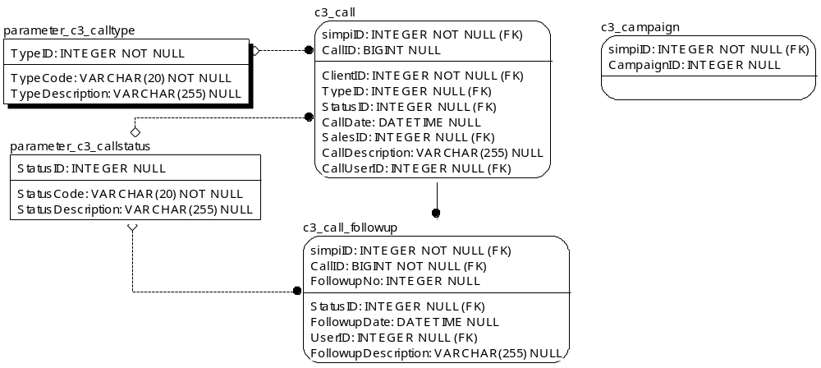

TABLE RELATIONSHIP
No | Table 1 | Table 2 | Type (1:1; 1:N; M:N) | Description
1. | parameter_c3_calltype | c3_call
2. | parameter_c3_callstatus | c3_call
3. | parameter_c3_callstatus | c3_call_followup
4. | c3_call | c3_call_followup

Name |  | parameter_c3_calltype
Objective
No | Column |  | Type | Rule  (PK, FK, Key, NN, Unik, Index) | Description
1. | TypeID |  | Integer | Null
2. | TypeCode |  | Varchar(20) | NN
3. | TypeDescription |  | Varchar(255) | Null

SAMPLE DATA
No | Column | Sample 1 | Sample 2 | Sample 3 | Sample 4
1. | TypeID
2. | TypeCode
3. | TypeDescription

Name |  | parameter_c3_callstatus
Objective
No | Column |  | Type | Rule  (PK, FK, Key, NN, Unik, Index) | Description
1. | StatusID |  | Integer | Null | Nomor ID dari cabang kantor
2. | StatusCode |  | Varchar(20) | NN | ID company yang sama dengan ID pusat
3. | StatusDescription |  | Varchar(255) | Null

SAMPLE DATA
No | Column | Sample 1 | Sample 2 | Sample 3 | Sample 4
1. | StatusID
2. | StatusCode
3. | StatusDescription

Name |  | c3_call
Objective
No | Column |  | Type | Rule  (PK, FK, Key, NN, Unik, Index) | Description
1 | simpiID |  | Integer | FK
2 | CallID |  | BIGInteger | Null
3 | ClientID |  | Integer | FK
4 | TypeID |  | Integer | FK, Null
5 | StatusID |  | Integer | FK, Null
6 | CallDate |  | DateTime | Null
7 | SalesID |  | Integer | FK, Null
8 | CallDescription |  | Varchar(255) | Null
9 | CallUserID |  | Integer | FK, Null

SAMPLE DATA
No | Column | Sample 1 | Sample 2 | Sample 3 | Sample 4
1. | simpiID
2. | CallID
3. | ClientID
4. | TypeID
5. | StatusID
6. | CallDate
7. | SalesID
8. | CallDescription
9. | CallUserID

Name |  | c3_call_followup
Objective
No | Column |  | Type | Rule  (PK, FK, Key, NN, Unik, Index) | Description
1. | simpiID |  | Integer | FK
2. | CallID |  | BIGInteger | FK
3. | FollowupNo |  | Integer | Null
4. | StatusID |  | Integer | FK, Null
5. | FollowupDate |  | Datetime | Null
6. | UserID |  | Integer | FK, Null
7. | FollowupDescription |  | Varchar(255) | Null

SAMPLE DATA
No | Column | Sample 1 | Sample 2 | Sample 3 | Sample 4
1. | simpiID
2. | CallID
3. | FollowupNo
4. | StatusID
5. | FollowupDate
6. | UserID
7. | FollowupDescription

Name |  | c3_campaign
Objective
No | Column |  | Type | Rule  (PK, FK, Key, NN, Unik, Index) | Description
1 | simpiID |  | Integer | FK
2 | CampaignID |  | Integer | Null

SAMPLE DATA
No | Column | Sample 1 | Sample 2 | Sample 3 | Sample 4
1. | simpiID
2. | CampaignID

